# Project Deliverables

## Conceptual modeling requirements

For all the entities you wish to store data about you must create ERDs to show the binary relationships between related entities, and then combine these ERDs to give the global view of the database system. All ERDs must be drawn by a modeling tool such as Visio and upload to the dropbox, a pdf or ms-word is also permitted.

# Database and tables requirements

1. Create the e-commerce database on Oracle1. Each table must include a primary key and all necessary fields. You must set the field properties as necessary to collect the current data. You must do a table design for each table showing a descriptive column name, data type, size, and constraints where necessary.
2. Use the prefix comm_ for each of your table names.
3. All products must belong to a category and products can have attributes such as colour or size.
4. Products must include prices.
5. The shopping cart must indicate products, prices and quantities and a status, i.e., checked out or not.
6. Customers must have relevant contact information.
7. Shipping may be to the home address or any other address. There must be a shipping status with a discreet set of values.
8. Populate each table with at least 10 records.
9. Design 5 different queries you need to make your project functional. Use SQL to create the queries.
10. Upload your database script file .sql which will also include your 5 queries to the project dropbox.

# Conceptual Modeling



# Tables - Screen Shots

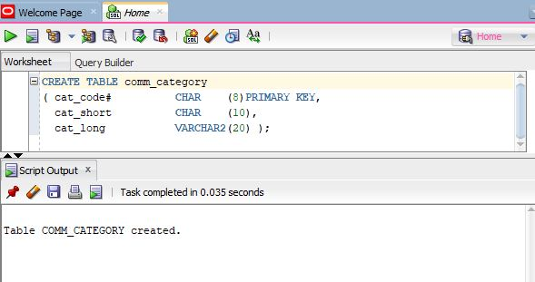

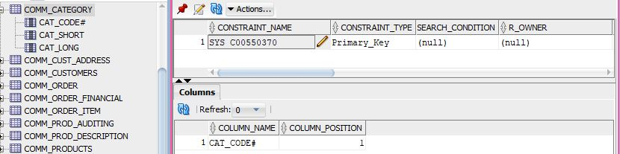

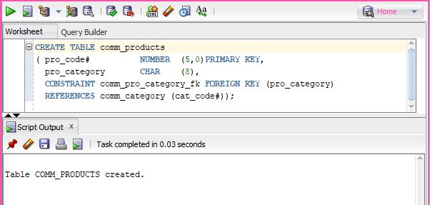

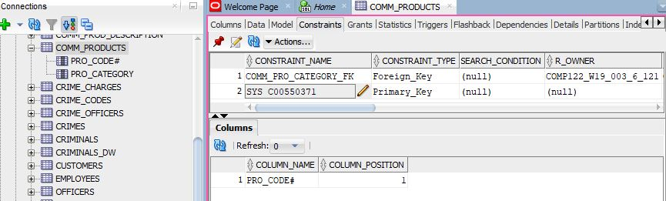

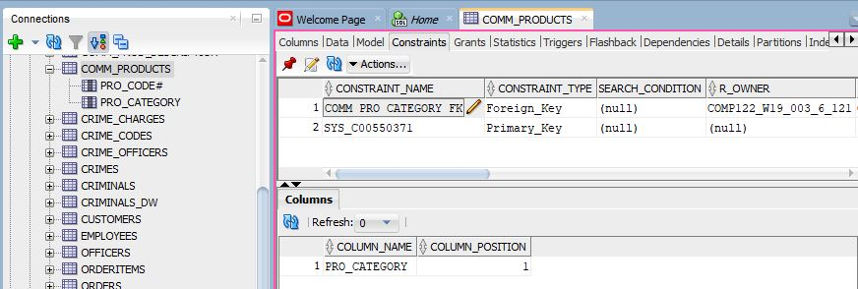

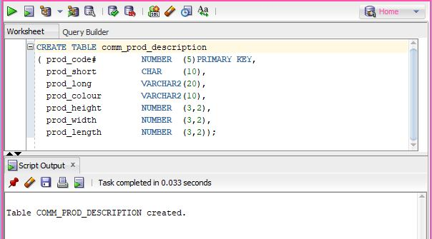

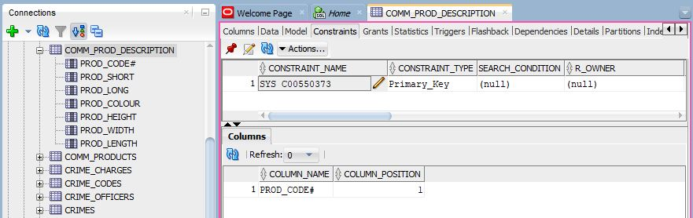

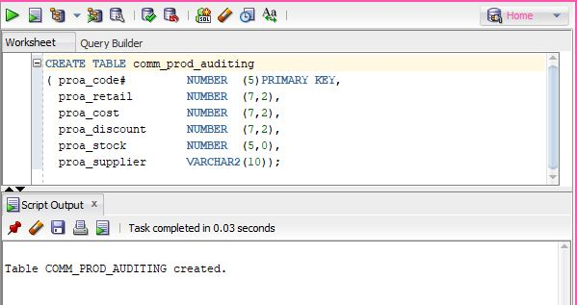

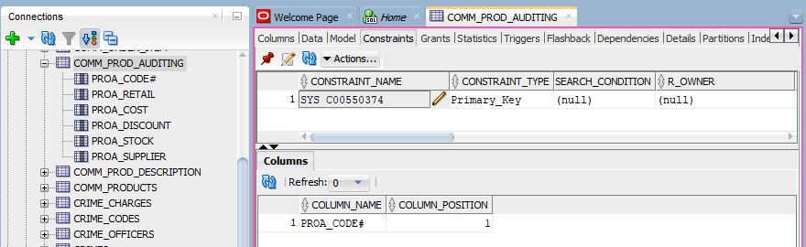

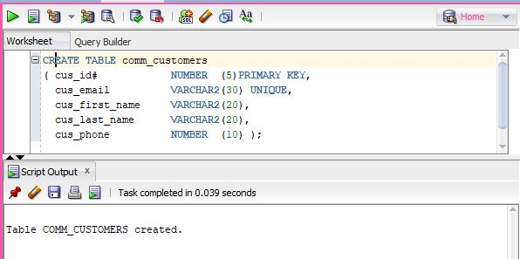

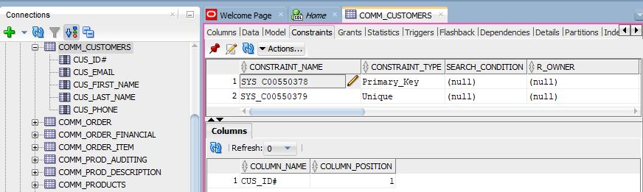

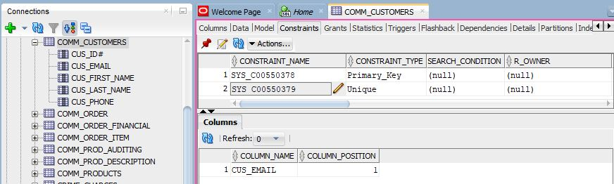

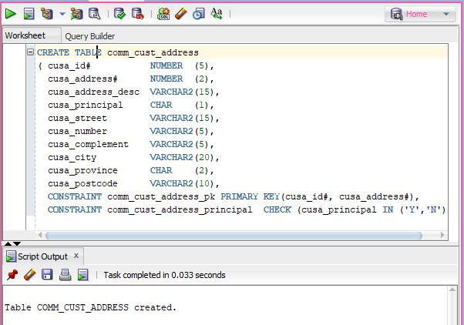

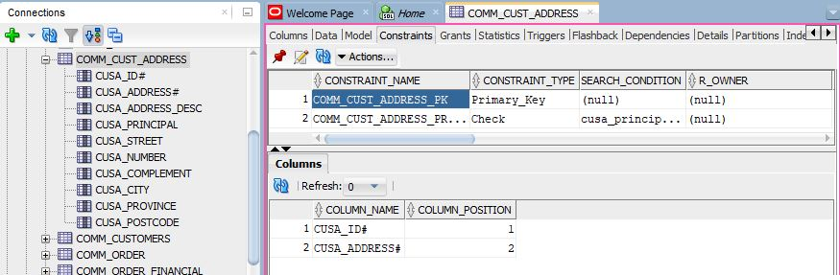

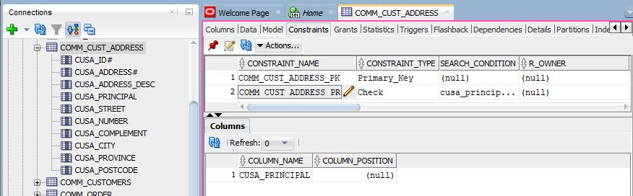

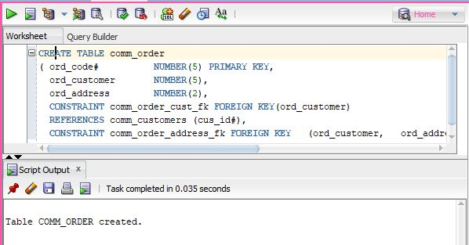

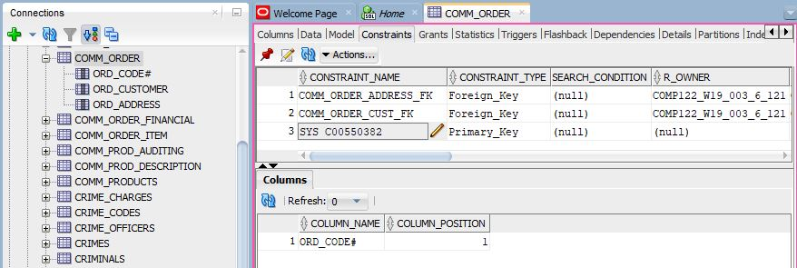

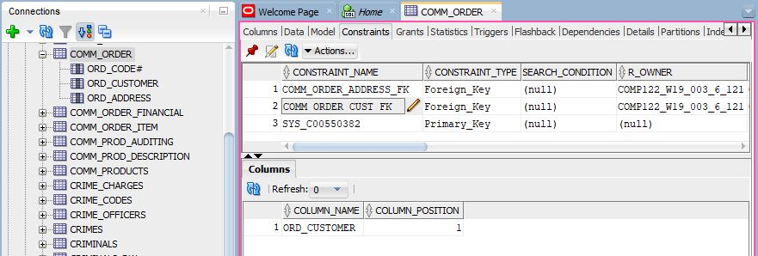

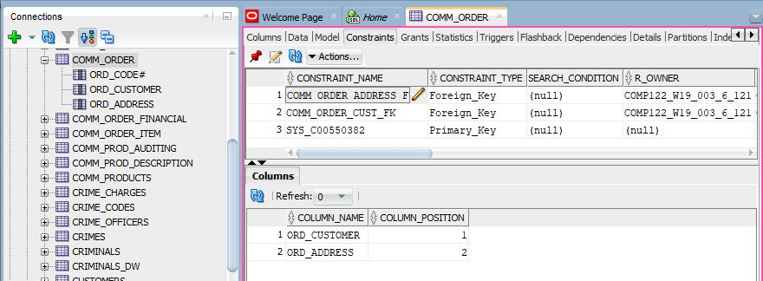

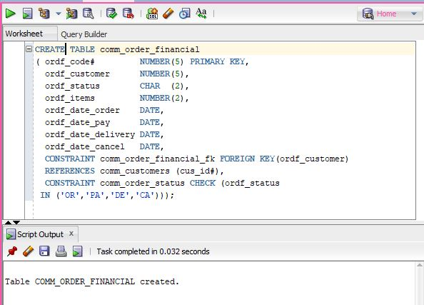

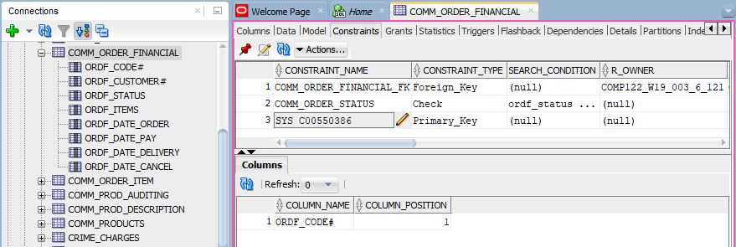

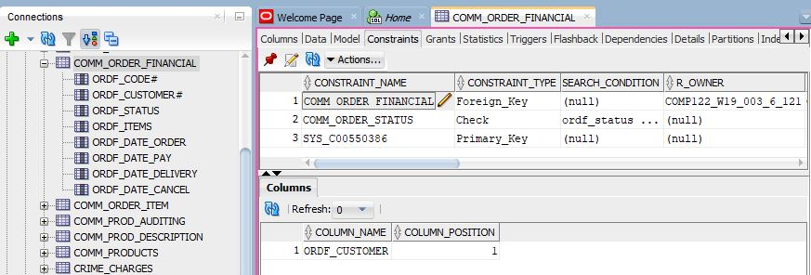

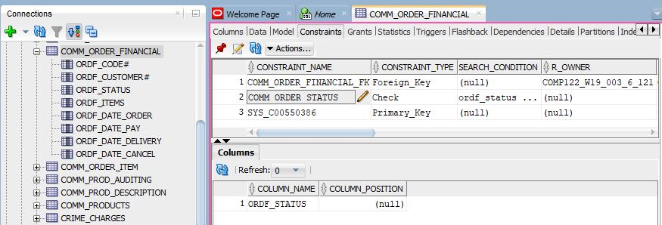

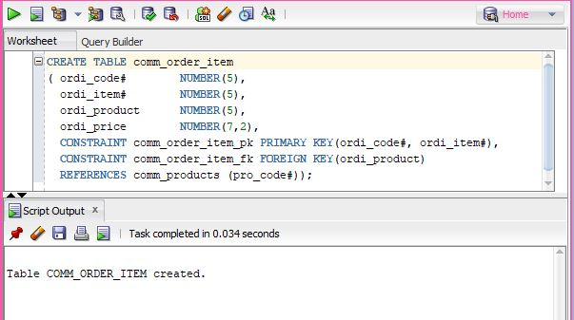

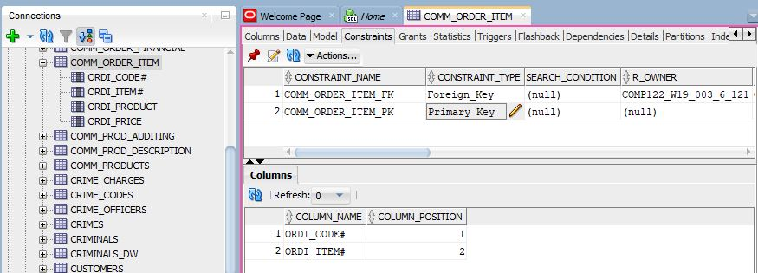

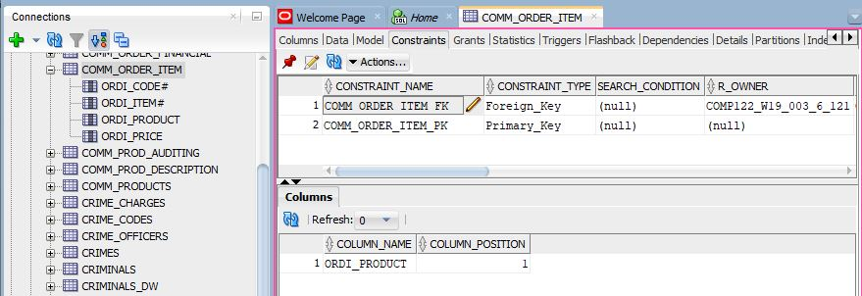

# Queries - Screen Shots

